Contents

Introduction 1

Technologies in the Industry 1

Existing Software in the Industry 1

Existing Hardware in the Industry 1

Emerging Technologies in the Industry 1

Legalities 1

Legalities in the Industry 1

Legalities in Application Development 1

# Introduction

I have recently been asked to propose a solution for Health Advice Group. I have created this documentation to share details about existing technologies implemented to solve similar solutions, and any potential legalities in the weather forecasting and health tracking industry.

# Technologies in the Industry

Firstly, it is important to consider any solutions which already solve a similar problem. This is because they could help with or inspire the design of our end solution. This could take multiple forms, such as software, hardware, or even emerging technologies such as IoT which can monitor and broadcast the weather or information about an end user’s health.

## Existing Software in the Health and Forecasting Industry

### MyFitnessPal

* Use case: MyFitnessPal is an app which is designed to measure a user’s physical activity and allows users to easily count and track how many calories they have consumed in a day.
* 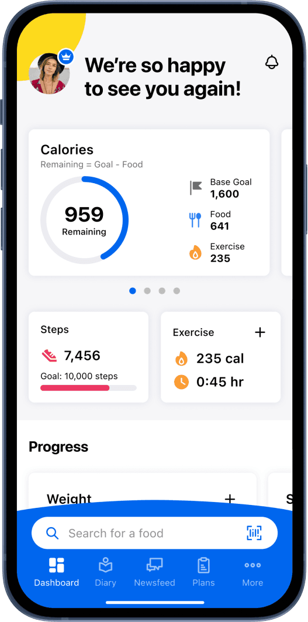Selling points and features: MyFitnessPal is a popular choice of app due to it’s ease of access through features such as a barcode scanner to easily find the exact food which you have bought. Additionally, MyFitnessPal can provide personalised calorie and nutrient goals dependent on whether a user wants to lose weight or bulk up.
* Pricing model: MyFitnessPal makes use of a freemium pricing model. This means that it offers some features for free, with some which can only be accessible by paying an annual subscription. The subscription for premium is $79.99 per year.

### A screenshot of a computer Description automatically generatedOpenWeatherMap

* Use case: OpenWeatherMap is an API which can return the current weather at a certain latitude and longitude. It is used by developers to display the weather in applications and digital solutions.
* Selling points and features: OpenWeatherMap is very easy to use and contains a lot of documentation for how to use it. Additionally, it has a large array of weather data in different formats depending on people’s needs.
* Pricing Model: OpenWeatherMap uses a freemium model, in which users can make a limited amount of API calls per minute, but they will have to pay to make more calls. Additionally, some APIs are limited behind a premium subscription, which ranges from £30 to £1500 per month.

## Existing Hardware in the Industry

## Emerging Technologies in the Industry

# Legalities

## Legalities in the Industry

## Legalities in Application Development